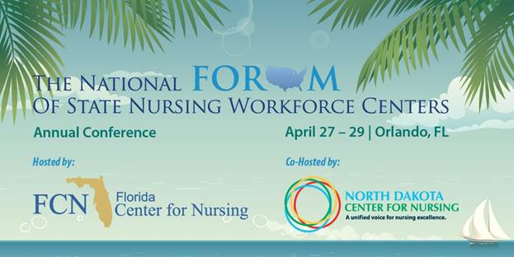

|  |  |
| --- | --- |
| |  | | --- | | **The National Forum of State Nursing Workforce Centers Annual Conference**  **Call for Abstracts - Podium & Poster**  The purpose of the 2016 conference is to improve collaboration, cooperation, and communication among workforce centers, healthcare agencies, and policy makers for successful population health outcomes through a strong health workforce. Join us in showcasing nursing initiatives that have been successful through collaboration, cooperation, and communication. Whether you are from a newly minted workforce center, an established center, or interested in transforming the nursing workforce, the conference will enhance your ability to be forward thinking in building successful relationships to advance nursing practice and the nursing workforce. | |
| |  | | --- | | **General Information: Call for Abstracts Related to the Conference**  [**Click here to download**](http://ndcenterfornursing.us10.list-manage2.com/track/click?u=2abdcaaeb57705ae2eeb494a6&id=e7ef69fdd8&e=8f7d72d524) complete abstract information and submission guide.   1. All proposals submitted will be blind reviewed and considered by a peer review committee for their potential contribution to the conference objectives. 2. Presenters will be notified of the outcome of the review committee by **February 8, 2016**, and must confirm their participation by **February 19, 2016**. 3. All presenters are expected to pay for their registration and travel expenses to the conference. 4. Contact hours will be awarded for these presentations, and, therefore the proposal will include two learner objectives (see the next section). 5. Presentations will be scheduled for either 30 or 60 minute sessions including time allowed for questions and answers. You may indicate a preference on your abstract form but the final determination will be made by the selection committee. 6. LCD projectors will be available for the presentations. 7. Proposals not accepted for presentation may be asked to do a poster presentation.   **Proposal Submission Guidelines**   1. Include two learner objectives (i.e., measurable outcomes of the presentation that complete the s sentence, “The learner will be able to….” each limited to 25 words or less). 2. All proposals must be no more than 350 words (excluding title, author names, and affiliations). 3. The proposal should be submitted in the following format:   •         The purpose or rationale  •         The background and significance  •         Methods and data  •         Major outcomes  •         Conclusions, including implications for collaboration   1. Contact and brief biographical information for each presenter should be included on a separate page.   **Selection Criteria**  Submission will be rated on the following:   * Overall quality * Focus or topic * Outcomes * Applicability to the Conference objectives:   o    Identify strategies and best practices for establishing successful collaborative relationships.  o    Describe the challenges and opportunities to enhance cooperation among similar and dissimilar groups.  o    Identify communication mechanisms to engage the larger audience and optimize the use of social media.  o    Demonstrate the relationship between the health workforce and population health outcomes.  o    Other nursing workforce issues or projects  Following the template ([**click here to download**](http://ndcenterfornursing.us10.list-manage.com/track/click?u=2abdcaaeb57705ae2eeb494a6&id=980fe9885d&e=8f7d72d524)**)** on pages 3- 4, complete the presentation proposal, based on the above guidelines and send by email attachment to Pam Lauer at [**TCNWS@dshs.texas.gov**](mailto:TCNWS@dshs.texas.gov) or call 512-776-6723.  Please do not put any identifying information on the proposal itself.  The title should appear on the proposal, but complete the contact and brief biographical information on page 4 of this document.                        **Abstracts are due November 30, 2015.** | |